**SQL Practice on Cricket Match Data**

**­­­­­­======================================================================**

**Qus 1: How many matches tied?**

**Ans:** Total 6 matches

**Syntax:****select** team1, team2, win_type **from** dim_match **where** win_type = 'Tie'

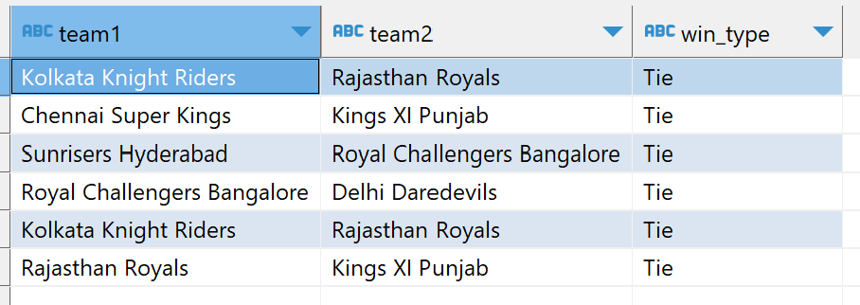

**Qus 2: Who became maxmium number of times man of the match?**

**Ans:** CH Gayle

**Syntax:****select** ManOfMach, **count** (ManOfMach) **as** player **from** dim_match **group** **by** ManOfMach **order** **by** player **desc** **limit** 1

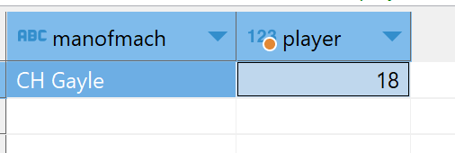

**Qus3. What are the most common ways of dismissal per each team?**